CAPSTONE PROJECT -DVD RENTAL DATABASE

**Overview of the project**

DVD Rental Database is to analyse the sales data and provide valuable insights for business intelligence and decision making.

* The analysis will focus on customer behavior, film inventory management, staff performance, and store operations.
* The goal is to enable data-driven decision-making and improve overall business performance.
* Will offer insights into customer segmentation, sales trends, film performance, staff productivity, and store revenue.

* The primary aim is to optimize film inventory
* Enhance customer satisfaction, improve staff performance, and streamline store operations.
* Provide actionable recommendations for targeted marketing campaigns, film collection enhancements.
* Staff training initiatives to improve business performance.

**Process**

1.**Data Acquisition from GitHub:**

Obtain the requisite dataset from a designated GitHub repository, containing essential information on university rankings, encompassing various countries and their performance across distinct ranking systems.

2. **Data Transformation and Enhancement:**

If necessary, execute data transformation procedures to ensure data quality and consistency. Additionally, consider augmenting the dataset with new problem statements to enrich the analysis potential.

3. **Connecting with Tools:**

Establish connections between the dataset and various analytical tools. Interface the dataset with Power BI, Excel, and MySQL Workbench, facilitating seamless data integration and processing.

4. **Problem Statement Solution in Power BI:**

Utilize Power BI to delve into the specified problem statements. Employ its robust features for data visualization, exploration, and analysis, effectively deriving insights and solutions

5**. Exploratory Data Analysis (EDA):**

Perform exploratory data analysis using either Excel or SQL Workbench, depending on the complexity of the analysis. Extract meaningful patterns, relationships, and trends from the data to inform subsequent decision-making.

6. **Creation of Visual and Insightful PowerPoint**:

Develop a comprehensive PowerPoint presentation that encapsulates the project's objectives, methodologies, problem statement solutions, and key visualizations. Each problem statement should be accompanied by a dedicated section with pertinent conclusions and insights.

7**. Detailed Documentation:**

Compile a detailed report that meticulously documents the entire project lifecycle. Include sections on data collection, transformation, problem statement formulation, tools integration, Power BI solutions, EDA insights, and PowerPoint visualizations.

**Objective**

The objective of this project is to create a comprehensive Power BI dashboard using the Sakila DVD Rental Store Database, providing valuable insights into the rental store business. The analysis will focus on customer behavior, film inventory management, staff performance, and store operations. The goal is to enable data-driven decision-making and improve overall business performance.

The project will involve the following tasks:

* The primary goal is to empower rental store owners with actionable insights.
* Aims to optimize film inventory, enhance customer satisfaction, improve staff performance, and streamline store operations.
* By understanding customer preferences and behavior, the goal is to offer personalized film recommendations and targeted marketing strategies to increase customer engagement and loyalty.

The success of the project will be measured by the following metrics:

* The quality of the analysis
* The relevance of the insights
* The impact of the recommendations

This project is significant because it has the potential to improve the sales performance and profitability of the company. By understanding the factors that influence rental store, the store can better position itself to succeed in the competitive market.

**Significance**

The DVD Rental database can also be used for creating various projects and reports that demonstrate the ability to apply data analysis skills and techniques to solve real-world problems and provide valuable insights for business intelligence and decision making.

**TABLE EXPLANATION**

### Table Explanations

#### Actor Table

The actor table lists information for all the actors, including first name and last name of actors.

#### Address Table

The address table contains address information for customers, staff, and stores.

#### Category Table

The category table lists the categories that can be assigned to films.

#### City Table

The city table contains a list of cities.

#### Country Table

The country table contains a list of countries or regions.

#### Customer Table

The customer table contains a list of all customers.

#### Film Table

The film table lists all the films that may be in stock in the store.

#### Film_text Table

The content of the film_text table is kept in synchrony with the film table by means of triggers on the film table INSERT, UPDATE, and DELETE operations.

#### Film_actor Table

The film_actor table is used to support many-to-many relationships between films and actors.

#### Film_category Table

The film_category table is used to support many-to-many relationships between films and categories.

#### Inventory Table

A row in the inventory table represents a copy of a given film in a given store.

#### Language Table

The language table lists all possible values for the film language and original language.

#### Payment Table

The payment table records every payment made by the customer, including information such as the amount and rent paid.

#### Rental Table

The rental table contains a row for each rental of each inventory item, which contains information about who rented what, when it rented it, and when it was returned.

#### Staff Table

The staff table lists all staff information, including email addresses, login information, and pictures.

#### Store Table

The store table lists all stores in the system.

**ER DIAGRAM**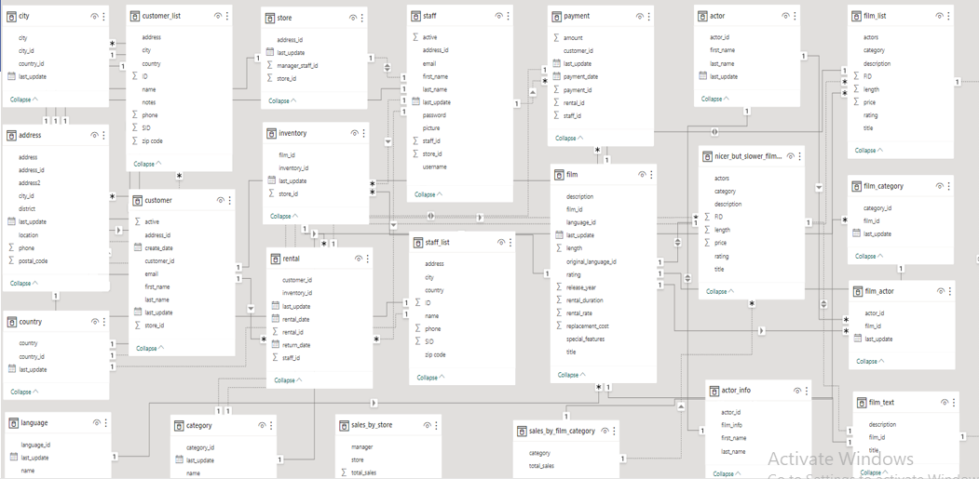

**Problem Statements**

**CUSTOMER AND SALES ANALYSIS**

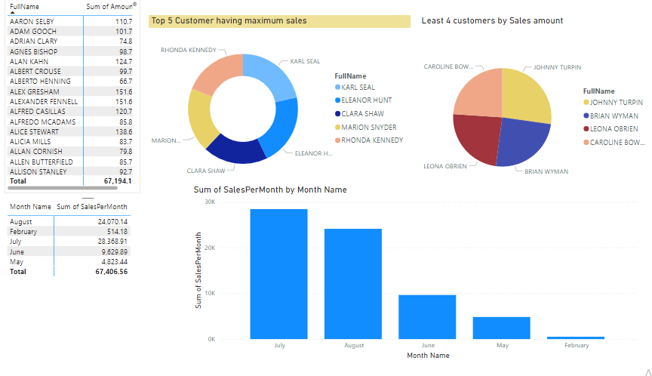

**Customer and SalesAnalysis**

1. How does the sales revenue vary by month?
2. Which customer segments generate the highest sales?

The dashboard analyzes the data of a DVD Rental database,

In which I have analysed the customers and its sales analysis

Over certain months and the customers who have higher

Payment amount.

I have also provided the TOP 5 customers in terms of sales revenue

And least 5 customers in terms of sales revenue.

Analysis of customers based on their months

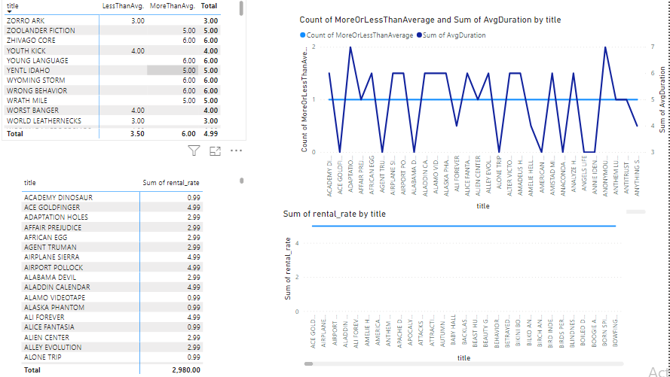

RENTAL AND FILMS ANALYSIS

PROBLEM STATEMENT

1. What is the distribution of films by rental duration?
2. Which film categories have the highest rental rates?

IN THIS DASHBOARD I HAVE ANALYSED THE FILMS

HAVING RENTAL DURATION MORE THAN AVERAGE

AND LESS THAN AVERAGE.

WE HAVE THREE TYPES OF RENTAL RATES

1.4.99 2. 2.99 3. 0.99

IN THE TABLES WE HAVE FILMS WITH RANTAL RATES AND

AND AVG RENTAL RATES.

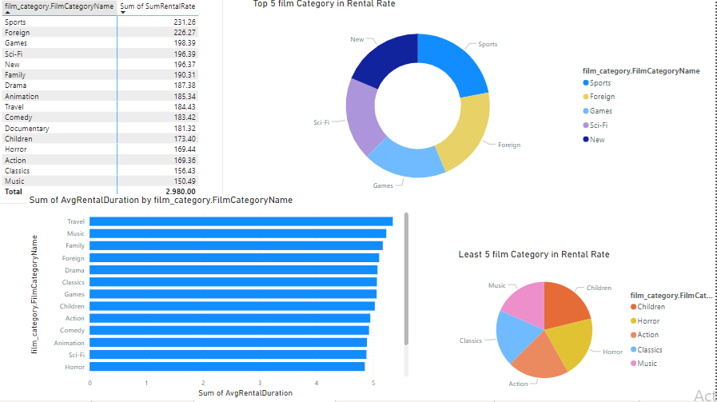

**FILM CATEGORY AND RENTAL ANALYTICS**

IN THIS I HAVE ANALYSED THE FILMS CATEGORY

BASED ON IT’S RENTAL RATE.

I HAVE ANALYSED THE THAT SPORTS CATEGORY HAS THE HIGHEST

RENTAL RATE .

MUSIC HAS THE LOWEST RENTAL RATE.

ALSO CREATED THE TOP 5 AND LEAST 5 IN TERMS OF FILM CATEGORY.

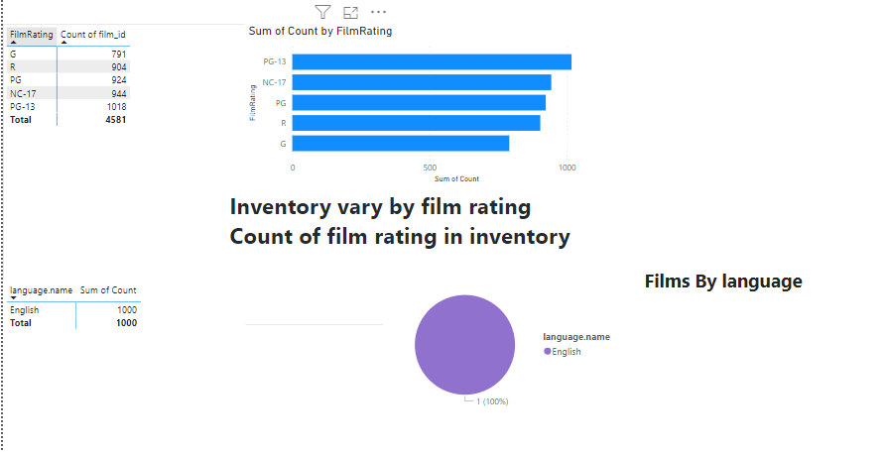

**FILM,INVENTORY AND LANGUAGE ANALYTICS**

IN THIS I HAVE ANALYSED THE FILM RATING

THE NUMBER OF FILMS PRESENT IN INVENTORY

BASED ON THEIR RATINGS.

AFTER ANALYSIS I OBSERVED ONLY ENGLISH LANGUAGE

FILM IS THERE IN THE INVENTORY.

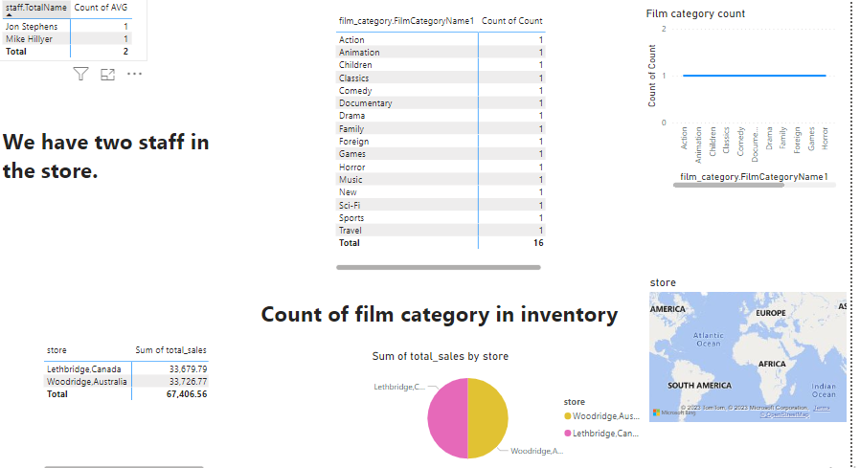

**STAFF , STORE AND INVENTORY ANALYSIS**

IN THIS I HAVE ANALYSED WE HAVE 2 STAFF MEMBER

IN THE STORES AND WE HAVE 16 FILM CATEGORY

PRESENT IN STORES.

I HAVE ANALYSED THE TOTAL SALES BY

EACH STORES.WE HAVE TWO STORES.

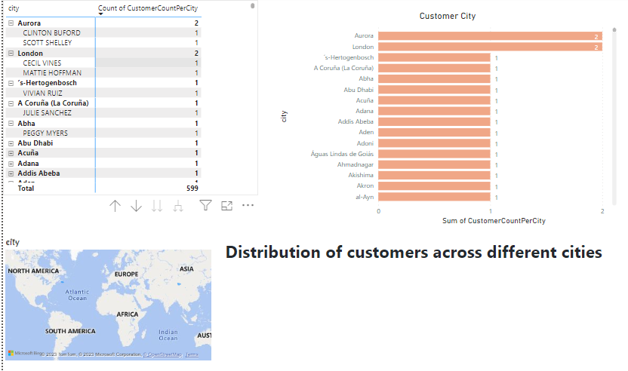

**CUSTOMERS AND DEMOGRAPHICS ANALYTICS**

WE HAVE CUSTOMERS ACROSS DIFFERENT LOCATION.

MOST OF THE CUSTOMERS ARE FROM DIFFERENT LOCATIONS

WE HAVE ONLY TWO CUSTOMERS FROM SAME CITIES

BUT THEY ARE ALSO DIFFERENT CUSTOERS

WE MOSTLY HAVE DIFFERENT CUSTOMERS

**EDA ANALYSIS**

1. What are the busiest hours or days for each store location, and how does it impact staffing requirements?

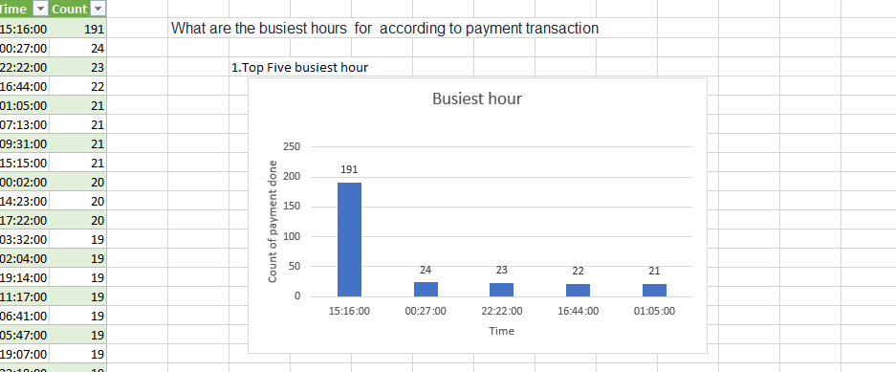

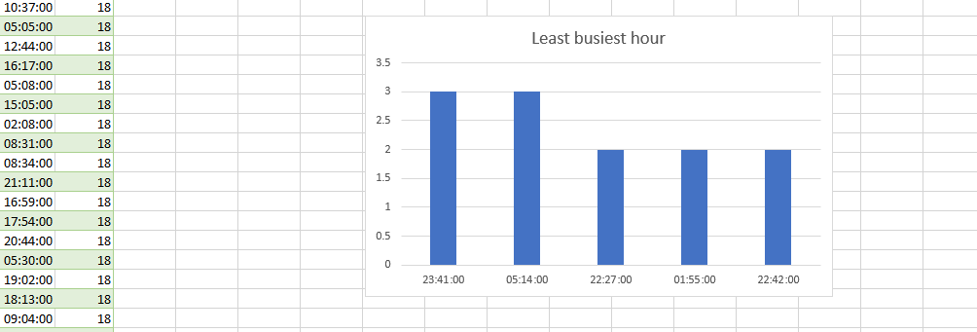

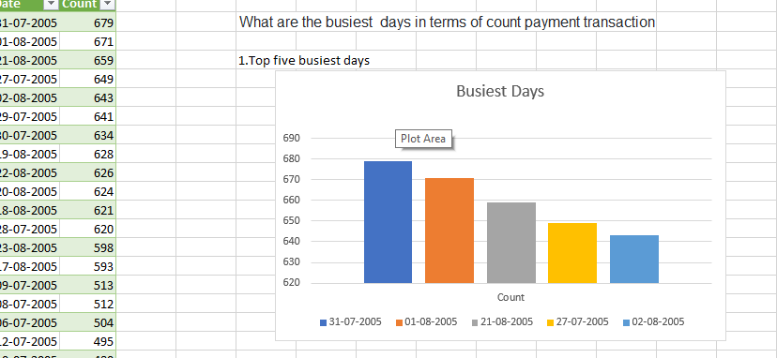

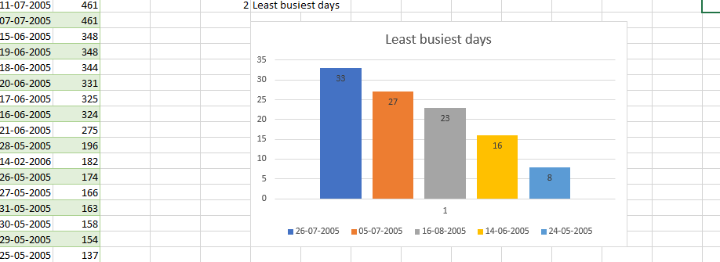

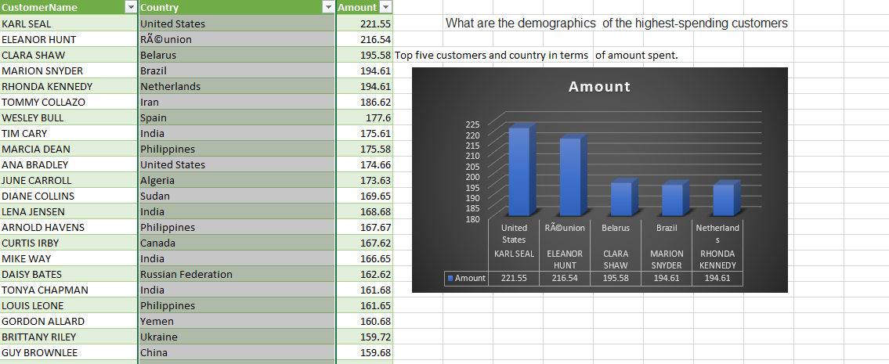

|  |  |  |
| --- | --- | --- |
| **Demographics of the highest-spending customer** |  |  |

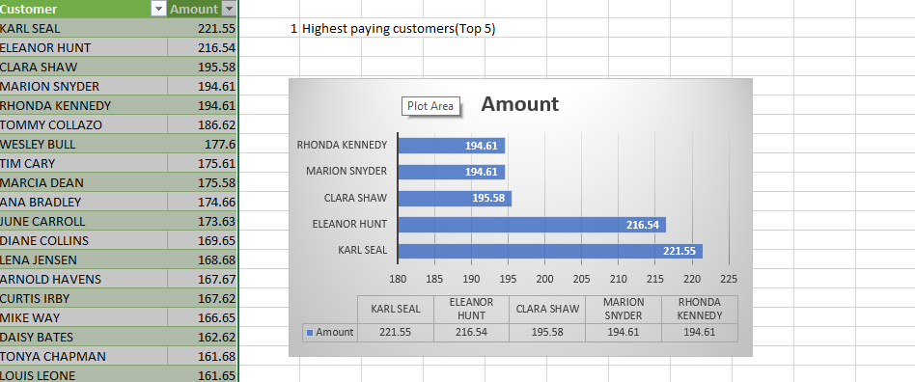

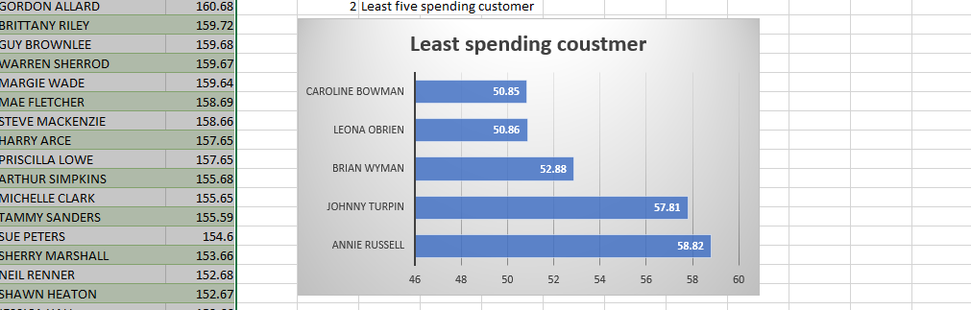

ANLYSIS OF CUSTOMER BASED ON SALES REVENUE

LEAST 5 CUSTOMERS AND HIGHEST PAYING CUSTOMERS.

CUSTOMER ACROSS DIFFERENT LOCATIONS

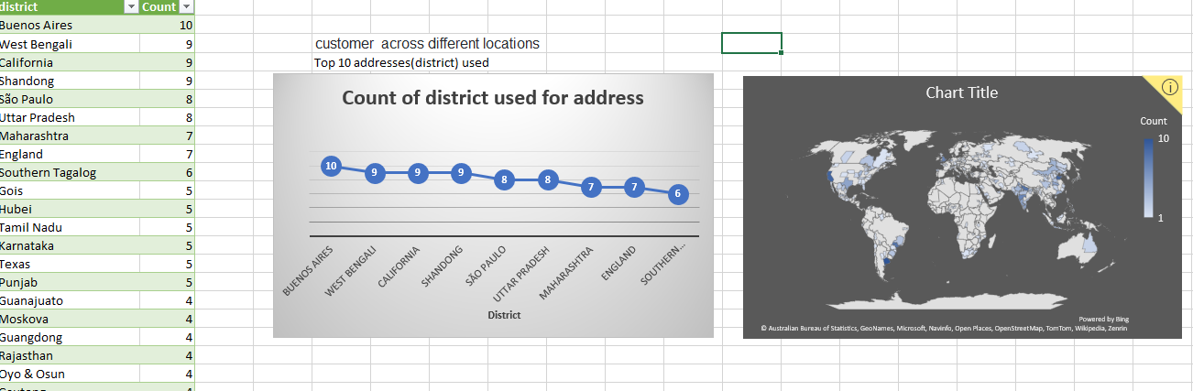

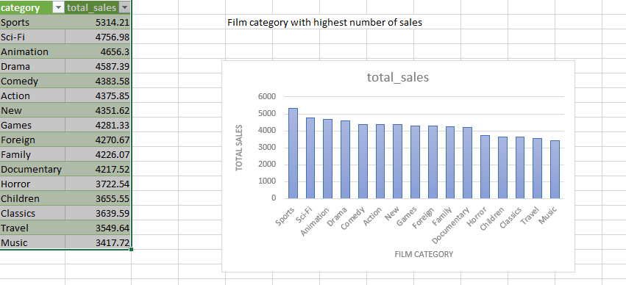

FILM CATEGORY WITH HIGHEST NO. OF

SALES

SPORTS IS HIGHEST AND MUSIC IS LOWEST.

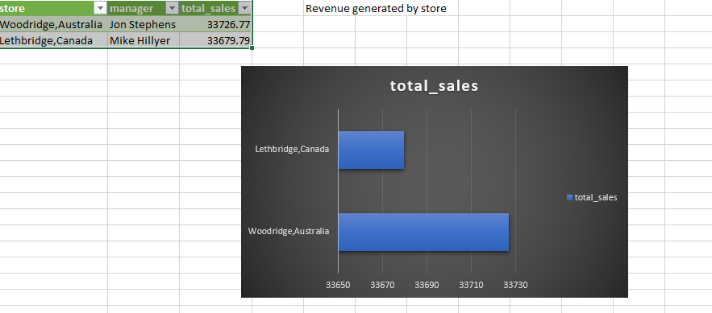  
   
REVENUE GENERATED BY STORE

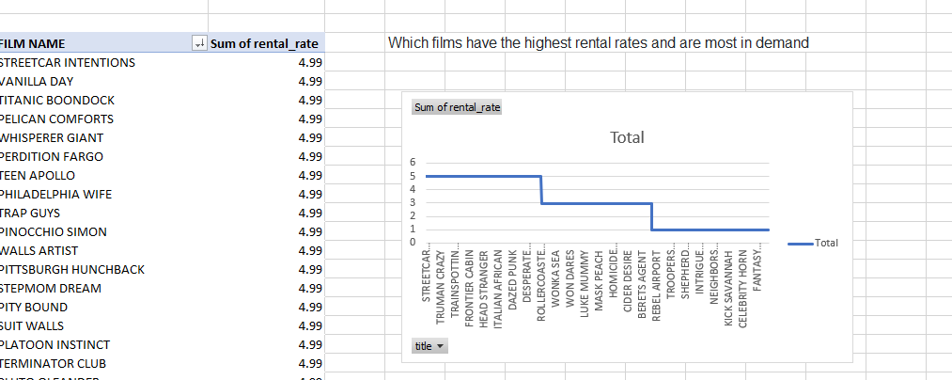

**HIGHEST RENTAL RATES OF FILMS**

SQL BASED ANALYSIS

1.

-- 1. Country wise customerno.

select country, count(customer_id) as totalCustomer

from country

inner join city on country.country_id=city.country_id

inner join address on city.city_id=address.city_id

inner join customer on address.address_id=customer.address_id

group by 1 order by 2 desc

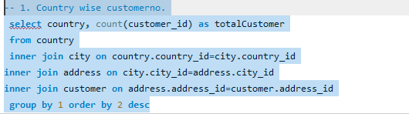

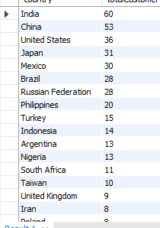

**2.Can we know how many distinct users have rented each genre?**

**SELECT c.name AS Genre, count(DISTINCT cu.customer_id) AS Total_rent_demand**

**FROM category c**

**JOIN film_category fc**

**USING(category_id)**

**JOIN film f**

**USING(film_id)**

**JOIN inventory i**

**USING(film_id)**

**JOIN rental r**

**USING(inventory_id)**

**JOIN customer cu**

**USING(customer_id)**

**GROUP BY 1**

**ORDER BY 2 DESC;**

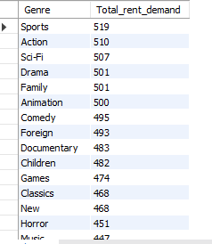

**3. Who are the top 5 customers per total sales and can we get their detail just in case Rent A Film want to reward them?**

**WITH t1 AS (SELECT *, first_name || ' ' || last_name AS full_name**

**FROM customer)**

**SELECT full_name, email, address, phone, city, country, sum(amount) AS total_purchase_in_currency**

**FROM t1**

**JOIN address**

**USING(address_id)**

**JOIN city**

**USING (city_id)**

**JOIN country**

**USING (country_id)**

**JOIN payment**

**USING(customer_id)**

**GROUP BY 1,2,3,4,5,6**

**ORDER BY 7 DESC**

**LIMIT 5;**

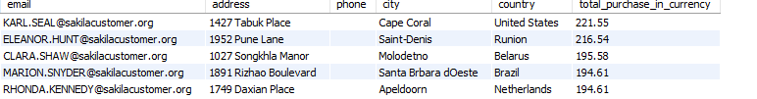

**CONCLUSION**

The company has sport-loving customers and they would be advisable to stock more sport-related films to increase total sales compared to music-related movies. It would be a good idea to increase the average rental rate of sport genre films since it is not a major factor in renting for the customers. This, in turn, increases total revenue.

DVD rental database consists of many clients where in order to satisfy client, we have to provide the code which satisfy their needs. This will help them to improve the product experience to their clients.

**RECOMMENDATION**

The data is segregated based on total revenue and baseline is provided with which we can increase the rating by taking preventive measures.

The company has sport-loving customers and they would be advisable to stock more sport-related films to increase total sales compared to music-related movies. It would be a good idea to increase the average rental rate of sport genre films since it is not a major factor in renting for the customers.